Baldwins Lane Surgery Patient Survey 2013

Patient surveys were handed out to patients by doctors and nursing staff and were available in reception for patients to complete. They were available for a 4 week period.
In total 53 completed surveys were received. Over 180 forms were given out but a number not returned.

The survey was geared to look at specific issues raised at the patient participation group together with changes that had been made in the past year. The patient group met on 12th December to discuss the issues they wanted to raise followed by the Patient Group Chairman helping to devise a survey whose results would be easy to interpret. The issues included the use of the internet and changes to reception area.
Results:
How do you normally book your appointments to see doctor of nurse at the surgery:
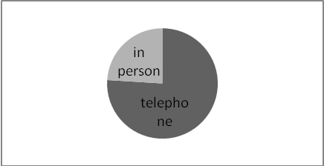
Do you have internet access?
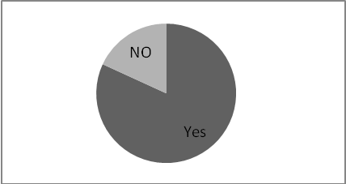
Which of the following methods would you prefer to use to book an appointment at the surgery?
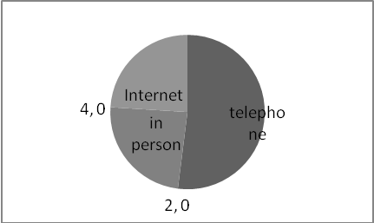
In the past how easy have you found the following:
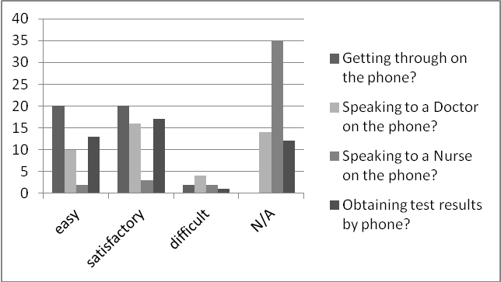

In the past 6 months how easy was it to book an appointment:
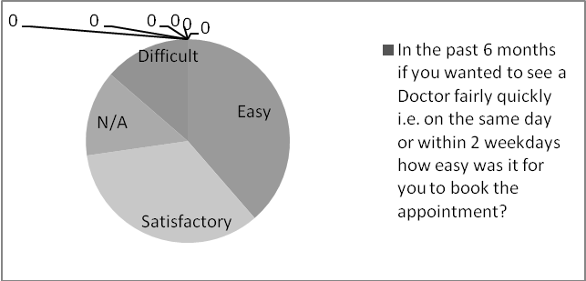
IN the past 6 months how easy was it for you to book ahead for a routine appointment?
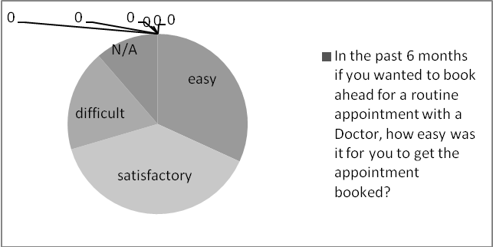

Are you aware of the current opening hours?
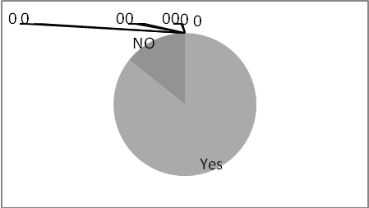
How easy is it for you gain access into the surgery?
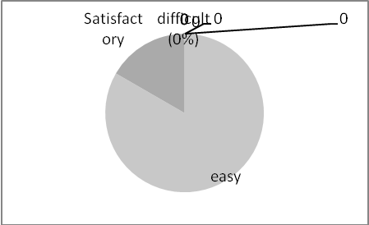

Regarding reception how good are the following:
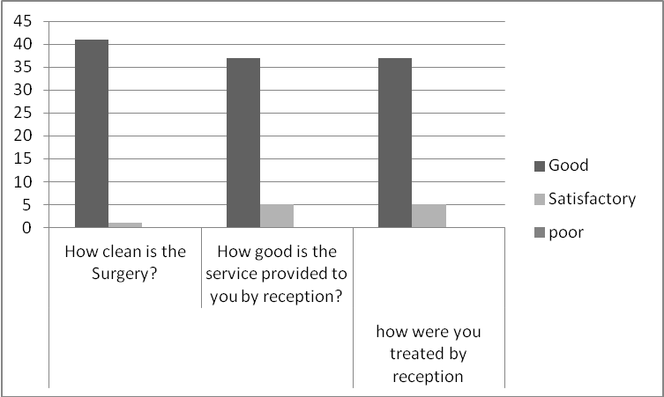
Do you like the changes made to reception and other areas over the last year
100% YES

Were you satisfied with the doctor allocated when you made your appointment?
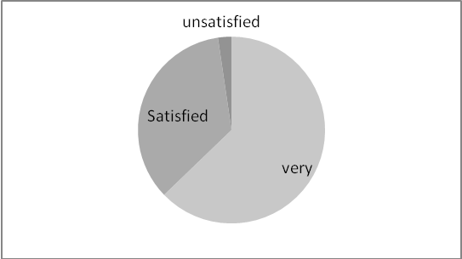
When you last saw a Doctor at the surgery how satisfied were you with the following?
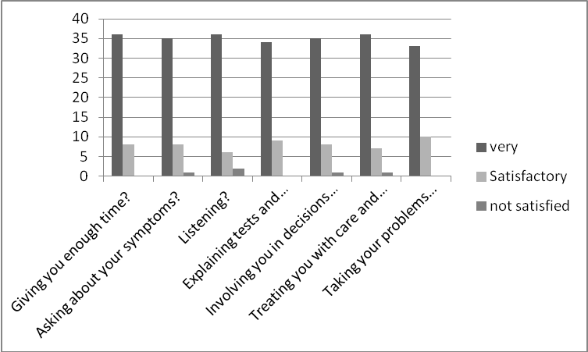
How easy was it for you to get an appointment with the practice nurse?
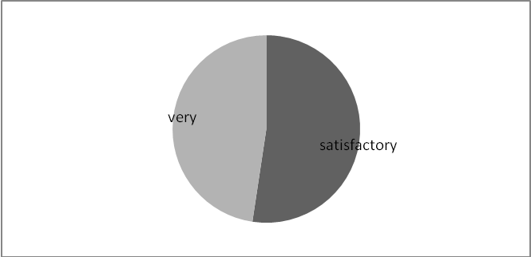

The last time you saw the nurse, how satisfied were you with the following?
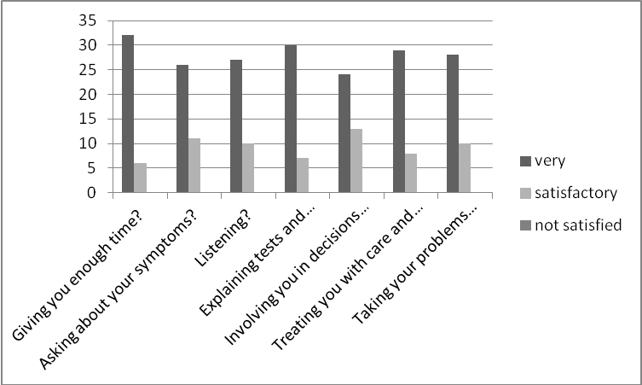

In general how satisfied are you with the care you receive at the surgery?
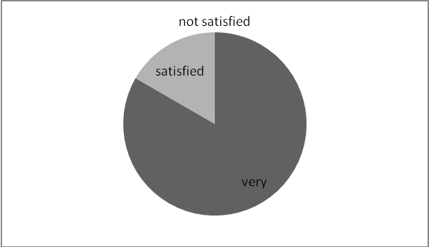
Would you recommend the surgery to someone who has just moved to the area?
Demographics:
Gender
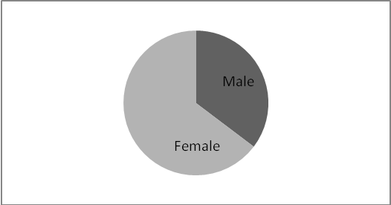
Employment
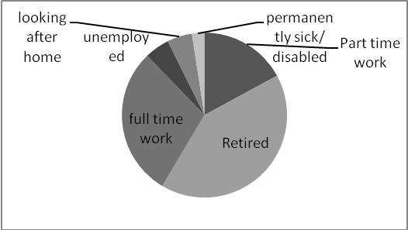
Long term conditions
Hearing impairment:!2%
Physical disability 12%
Psychological condition 2%
Other long term conditions 33%
No long term health conditions 30%
Ethnicity
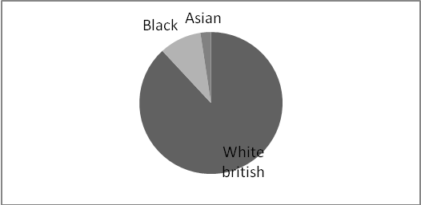
Summary
Following a further meeting of our patient participation group on 20 March 2013 we decided to look at the following key areas for our Action Plan:-
Internet access and whether online booking would be used. Over 80% of patients responded that they did have internet access so would if they wished be able to access online services. 30% expressed a preference for booking appointments online, the same percentage who prefer to book in person.
This is important as there is increasing pressure from government directives for patients to be able to access online services from their GP. We were concerned that due to our patient demographic with a large number of elderly patients that this would discriminate against them, but this shows that more than expected do have access to the internet.
We will investigate the process involved in setting up online booking services using EMIS Access and patient UK
Reception staff
Following last years’ survey there were concerns over the telephone manner and service provided by reception staff. As a result all reception staff underwent a training day and the survey shows that no one feels the way they are treated by reception is poor and 88% felt it was good.
Reception area
Last years’ survey highlighted issues with confidentiality and also the general reception area not being very open or friendly. We have undergone a major refit of the area with provision of a quiet area for telephone calls and also a more sound proof area between the waiting room and reception. 100% of respondents like the new changes.

Surgery Opening Times:-

The Surgery can be contacted by telephone from 08:00 to 18:30 on 01923 774732.
Our reception is open from 08:30 – 18:00.
Our surgery opening times are as currently published in our Practice Leaflet and on our Website.
We also offer Extended Hours which are currently 3 Monday evenings per month 18:30 – 20:30 and 1 Saturday morning per month 08:00 – 10:00.
In the event patients require emergency treatment outside of normal hours, care is provided by Herts Urgent Care who can be contacted via the 111 service provided locally.

